AMDP 101:
Supervisor: MC Barron 819-325-3333
Head Coach: Robbie Williams 778-793-5029
Schedulers: 604-905-2206
Thank you for coming to help.
Time Line:
7:30 – Meet in Whistler kids. Find head coach Robbie Williams. Picture attached:
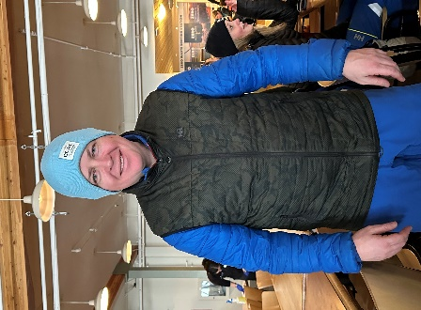
Scan Flaiks and barcodes. Make sure you know which barcode is assigned to which flaik.
Put flaiks into strpey orange and black bucket.
Pro Tip: Take photo next to flaik.
Pro Tip 2: String them together/use a carabiner. Remember your flaik to identify.

7:40 - Meet on the ECBC patio, ready to catch gondola. Upload with morning session.

8:00 – Meet at whistler lightboard for warmup. Spilt into groups for morning session.

9:00-9:05 – Meet kids. Put flaiks on legs and warm up.
Leave at 9:05, if there are kids missing alert MC and Robbie. Go for a warmup lap and check back in to the lightboard.
Spare flaiks go back in the bucket.

9:15-11:00 - Ski with group (Drills, skills and exercises)

11:00 - Lunch in roundhouse, Pikas.
Kids clean up after themselves.

11:30/45 - Back out to ski (guided mileage/adventure skiing)

2:30 - Meet at Whistler lightboard for first pickup.
No need for signatures but verbal feedback to parents. Collect flaiks.
13-18yos can be let go if waiver has been singed.
(Not all kids will be picked up in this location)

2:40-3:00 - Ski down/download to whistler village
Note: If athlete is going down to Creekside and has signed a release form they can be dropped at the top of Creekside gondola. Watch athlete download.

3:00 - Final pickup for remaining athletes. (As above)
9-12yos may leave from the bottom is release waiver has been signed.

3:00-3:10 – Return flaiks. Debrief with Robbie if any issues had occurred throughout the day.

AMDP Rules
- Nothing new after 2
- Buddy system for skiing trees
- No side hits on cat tracks, slow zones and in learning area’s
- Athletes are ok to ride chairs unsupervised if they can put the bar down. They have already received lift evacuation training.
- Don’t be afraid to refer to your safety manual (injury/separations, etc.)
- Terrain guidelines:
AMDP athletes have no terrain limitations. Terrain decision must be able to be justified.

